**AIM**

Write a C program to use MPI_Reduce that divides the processors into the group to find the addition independently.  
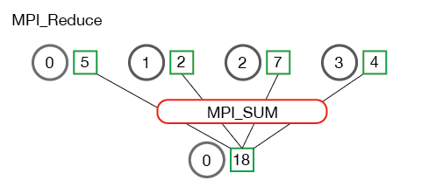

Hint. The function prototype is as follows:

MPI_Reduce(

void* send_data,

void* recv_data,

int count,

MPI_Datatype datatype,

MPI_Op op,

int root,

MPI_Comm communicator)

**Source Code**

**Execution**

**Remarks**